**Cryptography**

1. **The Numbers:**

**>>>>Download the File which is an (.png) file .....**

**By the help of the cmd of kali -> #eog the_numbers.png (eog== eye of genom)**

**As you can see there are the same formate as the ctf challenge something looks ... but it have NUMBERS loke as u can see ....**

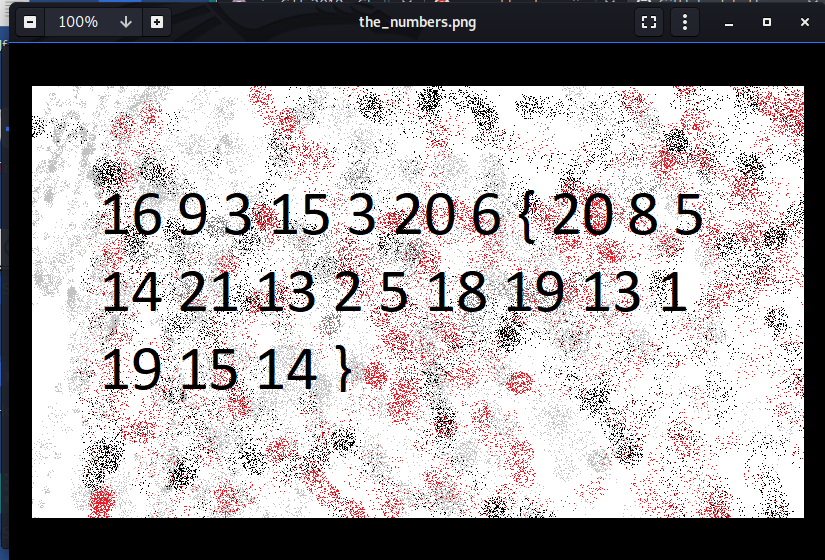

Now this is the Decimal you have to change to char by Mannually …

Run cmd #man ascii…… this type of the output will ….

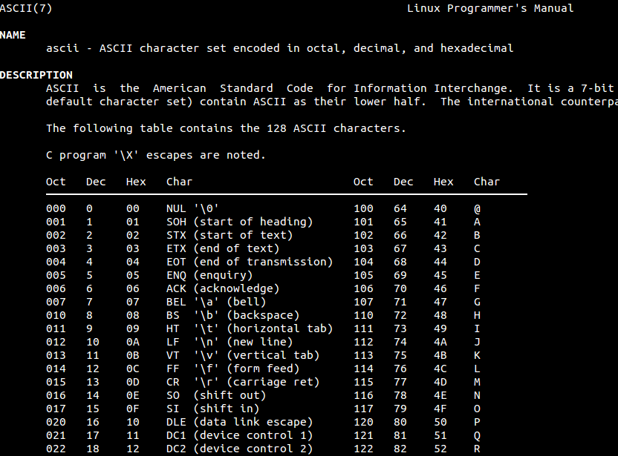

Now by the help of this table you can find out the char so …

16=P ; 9= I ;3=C …… so by this way you find your flag and submit it…

**2.13**

**Its so sim**ple …. As you can see in the problem statement it is already written …. This cipher is related to ROT13 :

cvpbPGS{abg_gbb_onq_bs_n_ceboyrz}

Now go to the ==== rot13.com

Paste this cipher and decrypt it you will get your flag……

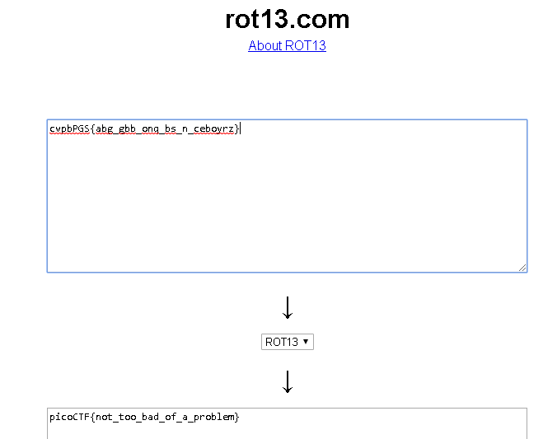

**3. Easy:**

**As you will download that table and If you have played many ctf then u will come to know that it is an….VIGRENERE CIPHER…**

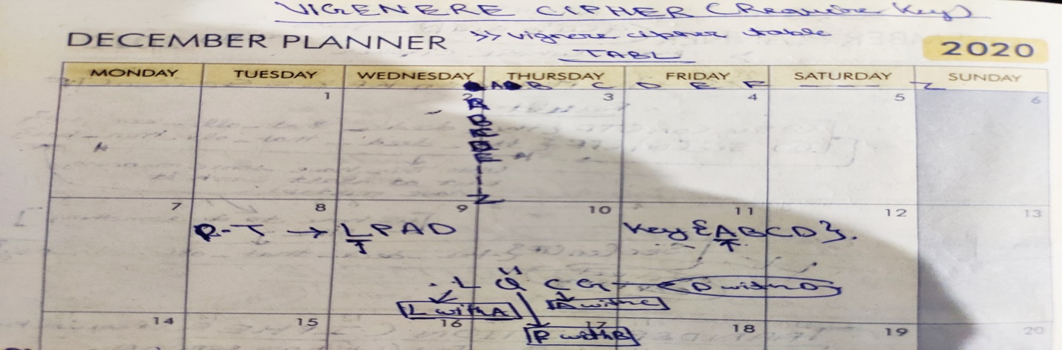

**>>>>>for these types of cipher in question there should be given some key ;**

**>>>>>if key not given then use Brute Force…..**

**Best Website for this >>>>** [**www.guballa.de**](http://www.guballa.de)

**>>>> U can also use decode fr (best website for any type of the cipher)**

<https://www.dcode.fr/vigenere-cipher>

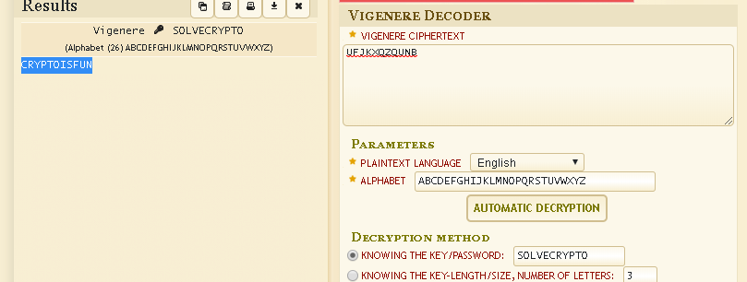

**4. Caesar**

**From the name it is representing that it can be the ceaser cipher so try for the ceaser cipher ……**

**picoCTF{odaeeuzsftqdgnuoazxvymiumq}**

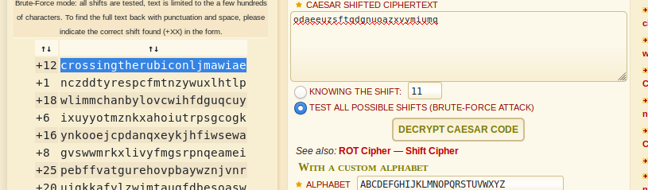

**5. Flags**

**In this challenge here it is given some flags which have some meaning in the character form …..**

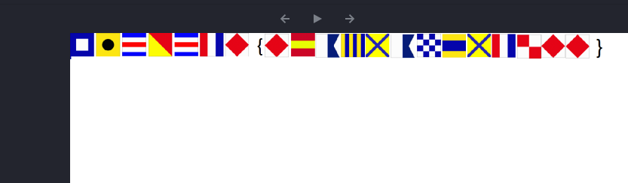

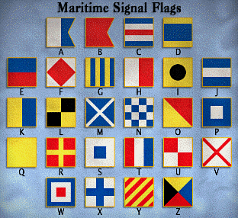

**>>>> You can decrypt it manually or ….. by the help of the website you can also decrypt it (decode fr )** <https://www.dcode.fr/maritime-signals-code>

**6. Mr World Wide**

**picoCTF{(35.028309, 135.753082)(46.469391, 30.740883)(39.758949, -84.191605)(41.015137, 28.979530)(24.466667, 54.366669)(3.140853, 101.693207)_(9.005401, 38.763611)(-3.989038, -79.203560)(52.377956, 4.897070)(41.085651, -73.858467)(57.790001, -152.407227)(31.205753, 29.924526)}**

**If u can see then it have given some coordinates .** **If take the first letter of the location matching each of the coordinates then we will get our flag……….**

**7.Tapping**

**nc 2019shell1.picoctf.com 49914**

**Just copy and paste it in your shell the u will get like these types of the msg….**

**.--. .. -.-. --- -.-. - ..-. { -- ----- .-. ... ...-- -.-. ----- -.. ...-- .---- ... ..-. ..- -. ----. ----- ...-- .---- ....- ----- ....- ....- ---.. }  
which look like same as the fromate of our challenge … Now examine this …**

**It is an MORSE CODE Which only represented with (dot,hippen)…**

**Now decrypt it by the use of again (decode fr) …**

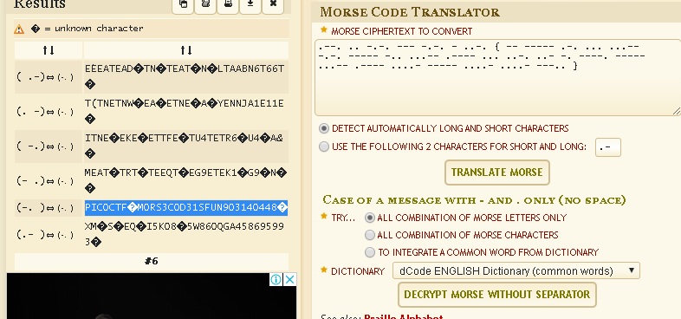

8. la cifra de

nc 2019shell1.picoctf.com 37608

copy paste it to your shell then u will get like these types of paragraph where your cipher txt is also hide… now lets solve it………….

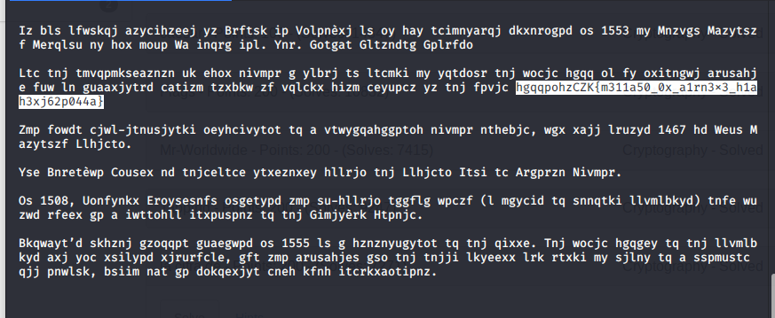

hgqqpohzCZK{m311a50_0x_a1rn3x3_h1ah3xj62p044a}

Now we are stuck we don’t have idea that how we can solve this encrypted flag then we have to do brute force ……..

When u will do brute force or only type the challenge then u will get to know that it is Vigrene Solver ….

Now here that >>>> www.guballa .de will work or >>> decode fr

Now decrypt it you will get your flag………………

**9.rsa-pop-quiz**

Now for this challenge you should have to know that what is the RSA ….

So read its algorithm then only u can solve this problem……..

